

MSP - 022

PROCEDURE FOR RISK MANAGEMENT

TABLE OF CONTENTS

TABLE OF CONTENTS 2
APPROVAL AUTHORITY 3
RECORD OF AMENDMENTS 4
DISTRIBUTION LIST 5
LIST OF ABBREVIATIONS 6
1. Objective 7
2. Scope 7
3. Responsibilities 7
4. Definitions 7
5. Procedure 8
5.1 Risk Identification 8
5.2 Risk Estimation 12
5.3 Risk Evaluation 12
5.4 Investigation of Adverse Risk Events (Risks) 14
6. Quality Control 14
7. Related Documents 14
8. Reference Regulations & Guidelines 14
9. Related Records 15

APPROVAL AUTHORITY

Prepared by: | Quality Manager | Dr. Sai Varun  Name | Date: 14/11/2024
 |  | Signature
Reviewed & Issued by: | Laboratory Head | Dr. Abdul Aleem  Name | Date: 14/11/2024

Signature
Approved by: | Chairman & Managing Director | Mr. Venkata Cherukuri  Name | Date: 14/11/2024
 |  | Signature

RECORD OF AMENDMENTS

S. No. | Ver. No. | Ver. Date | Rev. No. | Rev. Date | Description of Changes

Document Copy No. | Name / Designation of the holder of the document copy | Type of Copy | Version No. | Revision No.
01/10 | Managing Director | Controlled Copy | 01 | 00
02/10
03/10
04/10
05/10
06/10
07/10
08/10
09/10
10/10

DISTRIBUTION LIST

LIST OF ABBREVIATIONS
S. No. | Abbreviations | Expansion
1 | FMEA | Failure Mode and Effects Analysis
2 | FOL | Folder
3 | FOM | Form
4 | GE | General
5 | ISO | International Organization for Standardization
6 | MAN | Manual
7 | MSP | Management System Procedure
8 | NABL | National Accreditation Board for Testing and Calibration Laboratories
9 | QA | Quality Assurance
10 | QM | Quality Manager
11 | QO | Quality Officer
12 | RPN | Risk Priority Number
13 | SOP | Standard Operating Procedure
14 | TDPL | TRUSTlab Diagnostics Private Limited

- Objective
This procedure establishes guidelines for identifying and assessing potential conditions that may lead to errors in the laboratory. It outlines the necessary steps to prevent these errors, mitigate patient harm, and implement effective measures to control associated risks in the laboratory.
- Scope
The procedure stipulates guidance on risk identification, risk reporting, risk prioritization, risk estimation, risk evaluation and risk mitigation/management.
- Responsibilities
  - All lab personnel
  - QM
  - QO
  - Lab Manager
- Definitions
- Risk: The potential for harm to occur to a patient or the possibility of an error that can lead to patient harm. Risk can be estimated through a combination of the probability of harm and the severity of that harm. There are two methods to reduce the risk of harm to a patient: prevent the error from occurring which averts harm to the patient or detect the error before it can harm the patient.
- Risk Management: It is the systematic application of management policies, procedures, and practices to the tasks of analyzing, evaluating, controlling and monitoring risk.
- Risk Identification: Correctly identifying potential sources of error for a particular test reveals valuable information for developing an individualized quality control plan.
- Risk Assessment: A process that is, in turn, made up of three processes: risk identification, risk analysis, and risk evaluation.
- Risk Analysis: A process that is used to understand the nature, sources, and causes of the risks that you have identified and to estimate the level of risk. It is also used to study impacts and consequences and to examine the controls that currently exist.
- Risk Evaluation: A process that is used to compare risk analysis results with risk criteria in order to determine whether or not a specified level of risk is acceptable or tolerable.
- Risk Criteria: Terms of reference used to evaluate the significance or importance of laboratory risks. They are used to determine whether a specified level of risk is acceptable or tolerable.
- Risk Management Plan: Management plan, approach and the resources that will be used to manage risk.
- Risk Management Process: Systematic application of management policies, procedures and practices to a set of activities intended to establish the context, communicate and consult with stakeholders, and identifies, analyze, evaluate, treat, monitor and review risk.
- Sample: A biological specimen of a patient/test requestor that is received by TRUSTlab for specific diagnostic testing.
- Procedure

Risk Identification
- Correctly identify potential sources of error by developing a representation of all steps in a testing process through process mapping with consideration of all the testing phases of a sample; pre analytical, analytical and post analytical as shown below:
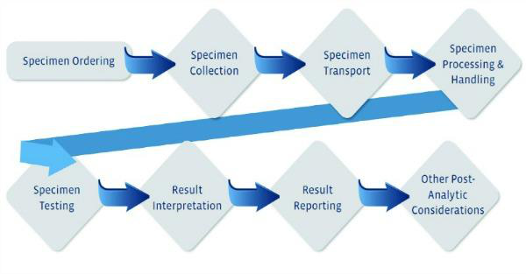
NOTE: Every diagnostic test poses different risks and may require varied control measures
- Identify the possible errors in all the identified processes.
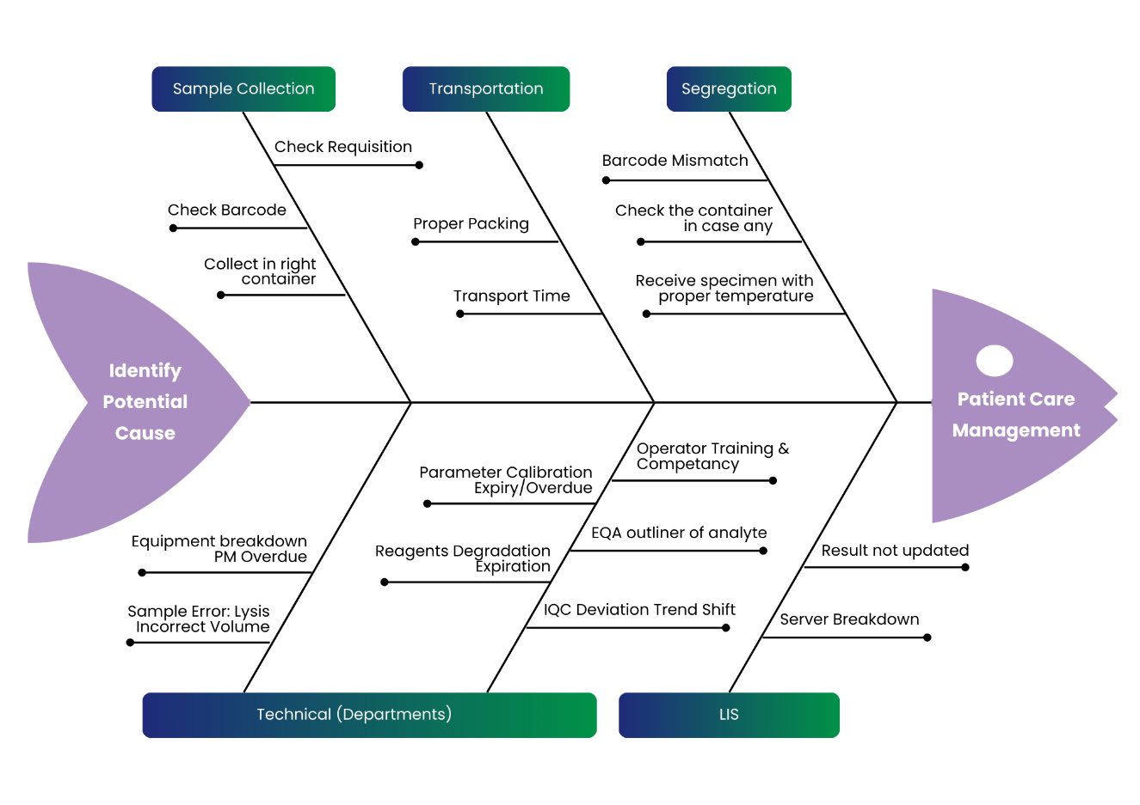
- Using the five components of the diagnostic testing process, narrow down the specific potential sources of error distributed and associated with these components key areas as shown in example of fish bone analysis below:
- Possible Risks (Potential Nonconformities) Associated with the core medical laboratory:
  - Pre-Examination Phase
    - Incorrect patient identification
    - Incorrect or missing diagnostic information
    - Incorrect interpretation of medical request
    - Incorrect patient preparation
    - Incorrect collection container or preservative
    - Incorrect collection container labelling
    - Incorrect phlebotomy technique
    - Incorrect mixing of sample
    - Incorrect collection timing
    - Incorrect transport conditions or timing
  - Examination Phase
    - Discrepant quality control result
    - Procedural non-conformity
    - Equipment or reagent error
    - Delayed time to completion (turnaround time)
NOTE: Time delays can occur throughout the total laboratory cycle.
    - Invalid quality control of equipment, reagents, materials
    - Personnel (active, cognitive, non-cognitive) errors
    - Latent (systemic) errors
    - The phase of verifying/validating the examination procedures:
- Insufficient or incorrect documentation of scientific evidence for analytic validity or clinical validity of any examination procedure.
- Not verifying or validating the examination procedure in appropriate patient population.
- Selecting inappropriate examination methods.
- Using incorrect or inappropriate reference values.
- Not using sufficient number and variety of samples in verification or validation.
- Incorrectly determined accuracy, analytic sensitivity and specificity, reportable range/cut-off values, etc.
- Non-optimized examination procedures.
    - No effective separation between specimens at dissection.
    - No confirmation that the specimen and request form details match before performing dissection.
    - More than one specimen pot opened at a time during dissection.
    - Inadequate checking at cut-up that the request form, specimen and cassette/s details match.
    - Designated area for cut-up does not provide a suitable environment to minimize distractions and interruptions.
    - Pre-labelling cassettes rather than single piece workflow at dissection.
    - More than one cassette open at a time for transfer of tissue at embedding.
    - Cases that require isolation/interruption to workflow at microtomy, such as for cooling or decal, not being effectively separated from other cases.
    - Pre-labelling slides before the embedded tissue is microtomed.
    - Tissue sections not cleared from the water bath between each block at microtomy.
    - Designated area for microtomy does not provide a suitable environment to minimize distractions and interruptions.
    - Using slide labels that do not survive subsequent staining processes and require replacement at the issuing stage.
    - No checks performed at the issuing stage to ensure that the macro appearance of the block correlates to the corresponding slide.
    - Specimens of the same tissue type are not effectively separated when cases are being assembled for microscopy.
    - Specimens of patients with the same or similar surnames are not separated when cases are being assembled for microscopy.
    - No checks performed to ensure that patient’s details on the slides and request form match prior to examination of the slides.
  - Post-Examination Phase
    - Incorrect result.
    - Incorrect transcription of result.
    - Ambiguous report.
    - Result ascribed to incorrect patient.
    - Report sent to incorrect person.
    - Missing information about restrictions on interpretations of result.
    - Details of any relevant discrepancies identified during the procedures, including pre-laboratory issues, not included on the final examination report.
    - Delayed reporting of examination results.
    - No mechanism in place for feedback and follow-up of discrepant anatomical pathology findings.

Risk Estimation
- The laboratory uses one of the following methods to perform risk management in various laboratory processes that include, but are not limited to, the following:
  - Failure Mode and Effects Analysis (FMEA)
  - Process Mapping
  - Fishbone Diagrams (more focused on a specific problem)
- Failure mode analysis is the most preferred method used by the laboratory. It has three (3) components used for evaluation as shown in the diagram below:
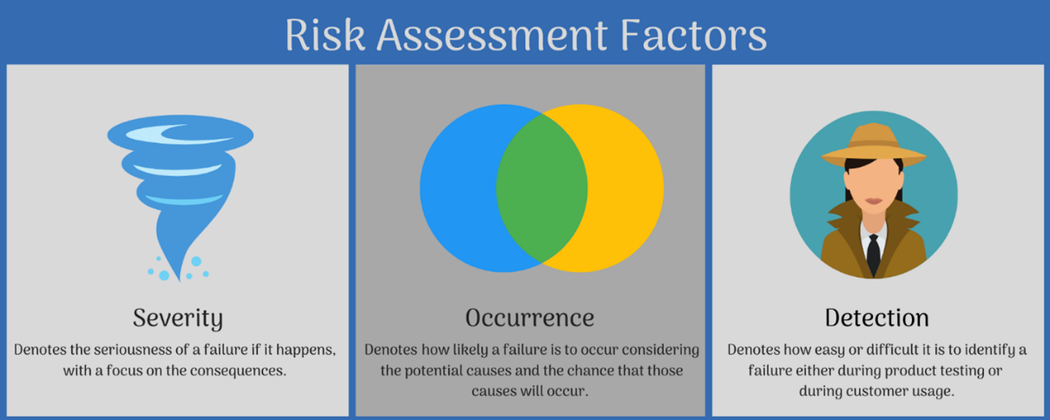

Risk Evaluation
- Risk evaluation is done by using scoring of the three components of FMEA which will be done according to the following Tables 1-3.
Table 1: Occurrence Scoring (O)
Score | Term | Frequency  (No. of failures vs activities) | Description | Practical Example
5 | Frequent | ≥ 1/1,000 | Likely to occur regularly with an examination procedure; expected to be experienced continuously in the laboratory. | Once a day
4 | Reasonably Likely | < 1/1,000 and  ≥1/10,000 | Likely to occur multiple times with the examination procedure; expected to be experienced frequently in the laboratory. | Once a week
3 | Occasional | < 1/10,000 and ≥1/100,000 | Likely to occur sometimes with the examination procedure; expected to be experienced several times in the lab. | Once a month
2 | Remote | < 1/100,000 and  ≥1/1,000,000 | Unlikely to occur but possible with the examination procedure; expected to be experienced only a few times in the laboratory. | Once a year
1 | Unlikely | < 1/1,000,000 and  ≥10,000,000 | Extremely unlikely to occur with the examination procedure; expected to be experienced only once or twice in the laboratory. | Less than once in a year or once in many years

Table 2: Severity Scoring (S)
Score | Term | Description
5 | Critical  (Catastrophic) | Life-threatening injury/death
4 | Serious  (Major) | Permanent (irreversible) bodily damage or impairment
3 | Significant  (Moderate) | Non-permanent bodily damage or impairment; reversible with medical intervention
2 | Marginal  (Minor) | Temporary bodily damage or impairment; reversible with no medical intervention
1 | Negligible  (Insignificant) | Temporary discomfort or inconsequential injury

Table 3: Detection Scoring (D)
Score | Term | Description/ practical examples
5 | Low or No Detectability | No ability to detect the failure
4 | Fair Detectability | Controls tested every 500 patient samples
3 | Likely to Detect | Controls tested every 100 patient samples
2 | Good Detectability | Controls tested every 50 patient samples
1 | High degree of Detectability | Controls tested together with each sample to detect any failure
- Risk evaluation and estimation for each section will be undertaken by staff in pairs where they will estimate probability of occurrence, severity, and detection of each risk. This will be documented on the Risk Assessment Check List (TDPL/QA/FOM-014).
- This will be undertaken at least once a year.
- Calculate the Risk Priority Number (RPN), which equals S × O × D. The highest possible RPN will be 125 while the lowest and ideal RPN will be 1.
- The results of RPN will be interpreted and actioned as follows:
 | MINOR RISK  (1-15) | MODERATE RISK  (16-30) | SIGNIFICANT RISK  (31-60) | MAJOR RISK  (61- 125)
Action | Minimal or no action may be required to be executed. | Action within 5-8 months. | Action/ within 2 – 3 months. | Immediate action to remove /reduce risks.

Investigation of Adverse Risk Events (Risks)
- The identified significant and major risks will be logged in the Risk Assessment Form (TDPL/QA/FOM-015).
- The Quality Manager assigns the responsibility of follow-up action of each risk to a designated staff member.
- The responsible staff member(s) will then undertake root cause analysis, initiate, and implement appropriate actions.
- Quality Control
The Quality Manager or designee will do random Quality Control checks to ensure that this SOP is implemented as written. If Quality control checks reveal non-compliance with this SOP, the SOP deviations and violations will be investigated, corrective and preventive action initiated, implemented, reviewed and closed out. All corrective and preventive action should be documented in the Non-Conformity & Corrective Action Form (TDPL/GE/FOM-021).
- Related Documents
Procedure for dealing with Nonconforming Work (TDPL/QA/MSP-018)
- Reference Regulations & Guidelines
  - Specific Criteria for Accreditation of Medical Laboratories (NABL 112 A; Issue 01)
  - Guidance document: Medical Laboratories (NABL 112B; Issue 01)
  - ISO 15189:2022 Medical Laboratories – Requirements for Quality and Competence
  - ISO 22367:2020 Medical laboratories – Application of risk management to medical laboratories.
  - ISO15189 Medical Laboratory requirements for quality and competence, 4th edition, reference no. ISO15189:2022(E)
  - Guidelines on Good Clinical Laboratory Practice; J Pharm Biomed Anal. Jan 7, 2018; 46(1): 18–29
- Related Records
  - Non-Conformity & Corrective Action Form (TDPL/GE/FOM-021)
  - Risk Assessment Check List (TDPL/QA/FOM-014)
  - Risk Assessment Form (TDPL/QA/FOM-015)

